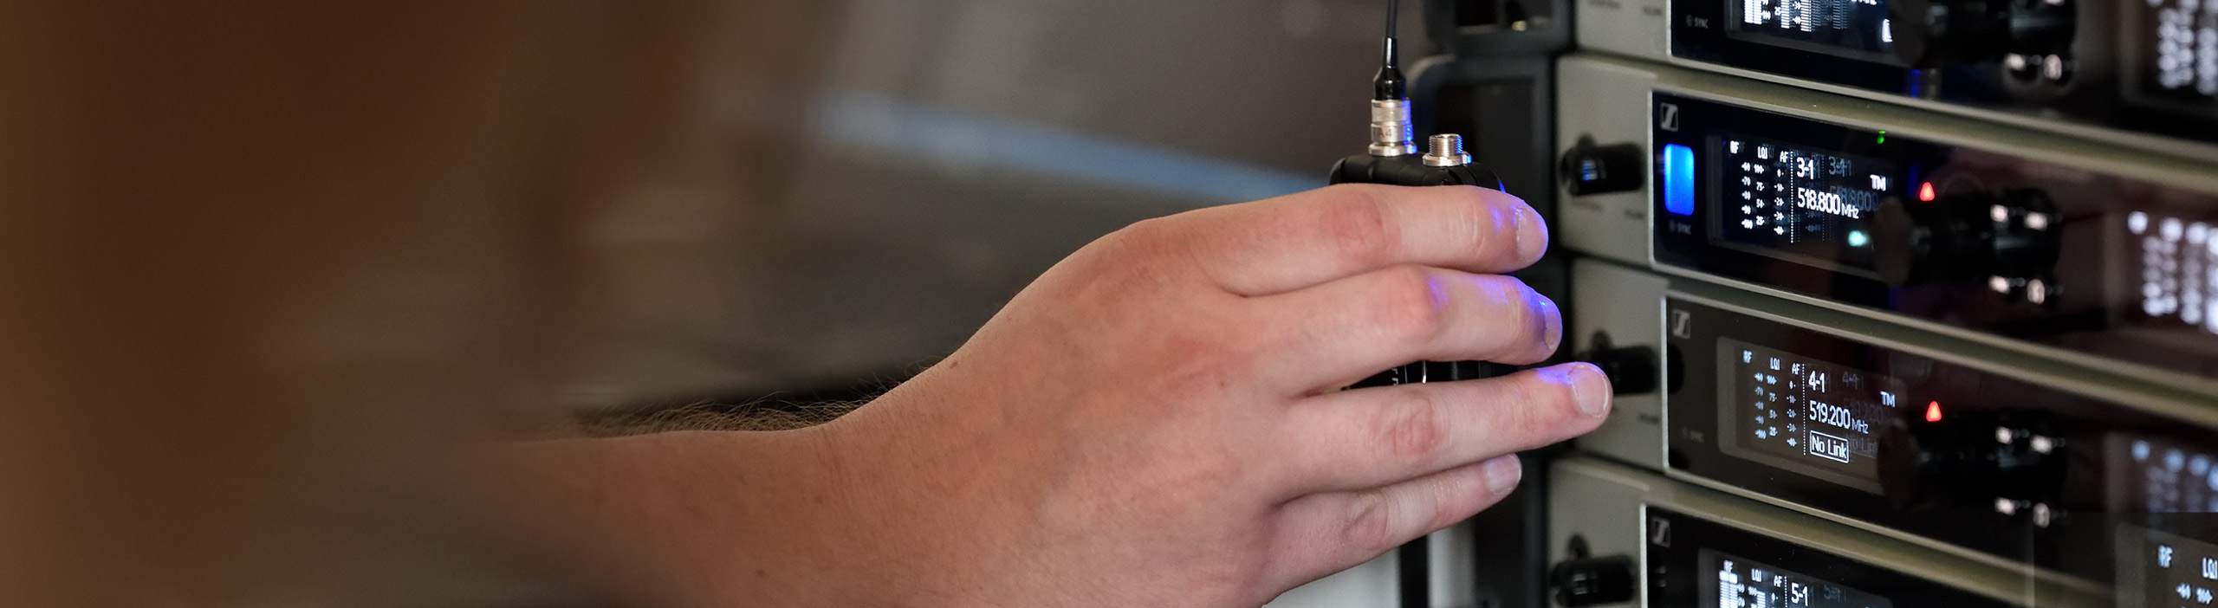

# #Dontstoptheeducation

## Audio for theatre – join a live discussion on audio production for theatres

***Sydney/Wedemark* – The Sennheiser SoundAcademy’s next round-table discussion will be all about theatre sound: On April 22 at 2:00 a.m. AEST, the Sennheiser Relationship Management team and guest host Jamie Criswell will be joined by leading professionals from Broadway and the West End.**

During the 90-minute webinar, Nevin Steinberg (Hadestown, Hamilton), Jessica Paz (Hadestown, Fela!), Scott Lehrer (South Pacific, Hello, Dolly!), Gareth Owen (Come From Away, MJ: The Musical) and Reese Kirsh (42nd Street, Back to the Future) will discuss their approach to Theatrical Audio and Sound Design and answer questions on a range of other topics. Please register at <https://zoom.us/webinar/register/WN_t1Ol87jvTiqjjRY5h3l3Ug>.

Ein Bild, das Foto, Person, darstellend, Mann enthält.

The panellists of the Audio for Theatre Round Table#1: Gareth Owen, Reese Kirsh, Nevin Steinberg, Jessica Paz and Scott Lehrer (from left to right)

**More about the panellists**

**Gareth Owen**

Gareth Owen started out in live audio before kicking off a theatre career with the musical The Blues Brothers and working as a sound designer. Gareth is a multiple Olivier Award winner and has created the sound design for many West End, Broadway and international musicals, including Come From Away, Memphis, Merrily We Roll Along, End of the Rainbow, Disney’s Hunchback of Notre-Dame, Sister Act and many more. With his own company, Gareth Owen Sound, he has collaborated with many of the greatest contemporary composers. Gareth has also worked with various orchestras including the Royal Philharmonic Orchestra and the New York Philharmonic and has mixed for Def Leppard, The Rolling Stones, Justin Bieber, Elton John and many more.

**Reese Kirsh**

Reese is a graduate from the Liverpool Institute for Performing Arts. He worked on a variety of shows both in London and touring nationally and internationally before progressing to Head of Sound on musicals such as Come From Away, 42nd Street and most recently the world premiere of Back to the Future.

**Nevin Steinberg**

A seasoned Broadway sound designer, Nevin is a passionate collaborator on a wide range of live events and theatre productions. His recent Broadway projects include the contemporary smash Dear Evan Hansen, the blockbuster Hamilton and the beautiful Bright Star with Steve Martin and Edie Brickell, It Shoulda Been You at The Brooks Atkinson, and Terrence McNally’s Mothers and Sons. In addition to his theatre design, Nevin serves as the Audio Consultant for Stern Auditorium at Carnegie Hall. In 2019, Nevin won a Tony Award for “Best Sound Design of a Musical” for Hadestown.

**Jessica Paz**

Jessica Paz is a Tony Award-winning Sound Designer for theatre, film and music. Most recently, she collaborated with Nevin Steinberg on the sound design for Anaïs Mitchell’s acclaimed production of Hadestown, which earned the duo a Tony Award, Drama Desk Award and an Outer Critics Circle nomination. On Broadway, Jessica was an Associate Sound Designer on projects including Dear Evan Hansen, Bandstand, Disaster! The Musical; The Assembled Parties (MCC); and Fela!. Jessica is also a front-of-house engineer for musicians and loves to take innovative approaches from music recording to her theatre work.

**Scott Lehrer**

Scott is a Tony and Grammy Award-winning sound designer, audio engineer and music producer. He has designed sound for more than 100 theatre productions – Broadway, off-Broadway, national and international tours and received a Tony Award for South Pacific. Scott also has a long track record with media projects and has mixed, engineered and/or produced more than 90 music projects from independent artists to Broadway Cast recordings. He runs a professional recording studio in New York City.

**Expand your expertise with more webinars – totally free**

In addition to round tables, Sennheiser’s SoundAcademy provides a host of other popular pro audio training webinars and in-depth product discussions. Please visit <https://www.sennheiser.com/webinars> for a full, up-to-date list and to register free of charge for a SoundAcademy webinar of your choice. The free training sessions are offered at several different times to allow as many people from around the globe to tune in as possible.

[](https://www.sennheiser.com/webinars)

**About Sennheiser**

Founded in 1945, Sennheiser is celebrating its 75th anniversary this year. Shaping the future of audio and creating unique sound experiences for customers – this aim unites Sennheiser employees and partners worldwide. The independent family company, which is managed in the third generation by Dr. Andreas Sennheiser and Daniel Sennheiser, is today one of the world’s leading manufacturers of headphones, loudspeakers, microphones and wireless transmission systems. In 2018, the Sennheiser Group generated turnover totaling €710.7 million. www.sennheiser.com

**Global Press Contact**

Stephanie Schmidt

Stephanie.schmidt@sennheiser.com

+49 (5130) 600 – 1275

**Local Press Contact**

Gabby Wallace

[gabby.wallace@hausmann.com.au](mailto:gabby.wallace@hausmann.com.au)

+ 0431 045 932